Problems for Lab 2

1. Using functions available in graphics.h, display the following
   1. Point
   2. Line
   3. Circle
   4. Ellipse
   5. Triangle
   6. Rectangle

Manu Driven C program, using switch-case, needs to be written to choose the option of drawing above mentioned graphics primitives. Good modularity (separate function for each graphics primitive) is required.

1. Write a C program using graphics.h to draw the following figure. The dimension of the primitives can be chosen as you wish.

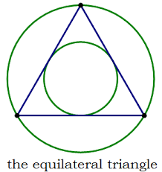

3) Write a C program using graphics.h to draw the following smiley

